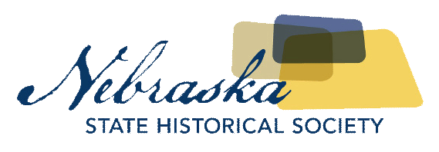

|  |  |  |  |  |  |  |  |  |  |  |  |  |  |
| --- | --- | --- | --- | --- | --- | --- | --- | --- | --- | --- | --- | --- | --- |
| |  |  | | --- | --- | | Contact | Chris Goforth | | Telephone | 402-471-3262 | | Cell | 402-219-3597 | | Email | chris.goforth@nebraska.gov | | Website | <http://history.nebraska.gov> | |  |  | | FOR IMMEDIATE RELEASEJanuary 8, 2018 |

Nebraska History Museum Exhibit to highlight photographer jim lommasson and yazidi community

“What We Carried: Lincoln” Opens January 26, 2018

Lincoln, NE, January 8, 2018– Lincoln, Nebraska is currently home to the largest population of Yazidi (Yah-ZEE-dee) peoples in the United States. The Nebraska History Museum will open an exhibit highlighting the Yazidi immigration to Nebraska with a focus on the items they brought with them. *What We Carried: Lincoln* is a collaborative photographic storytelling project comprising the Yazidi community and photographer Jim Lommasson. The project began in early months of 2017 when Lommasson participated in an exhibit on war at the Sheldon Museum of Art in Lincoln.

Lommasson, who worked with Nebraska Mosaic, a class in the UNL College of Journalism and the Yazidi community, asked the Yazidis to share an item they brought with them on their journey from Northern Iraq to the United States. He then created a photograph and requested that each owner write their personal reflections directly on the photograph. The project aims to present the experiences of refugees and create a platform for further discussion.

Lommasson says he hopes this exhibit helps people understand the hardships Yazidi immigrant’s experience when they leave their homes with only a handful of possessions. “I want to put us in the shoes of the refugees. Once we start asking ourselves these questions, we also start to realize what we are leaving behind. That’s the bigger picture. I hope when people view these photographs, it really puts ourselves in other people’s shoes and that’s how we can build those bridges.”

The Nebraska History Museum will present *What We Carried: Lincoln* January 26th, 2018 through May 25th, 2018. Museum hours are Monday through Friday 10am – 5:30pm, Saturday 1pm – 5:30pm, and closed Sundays. For more information and photographs of exhibit items, go to history.nebraska.gov/museum.

About The Nebraska State Historical Society  
The Nebraska State Historical Society (NSHS) collects, preserves, and opens to all the histories we share.  In addition to the Nebraska History Museum in Lincoln and historic sites around the state, NSHS administers the State Archives and Library; the State Historic Preservation Office; the Gerald R. Ford Conservation Center, Omaha; the Office of the State Archeologist; publishes *Nebraska History* magazine and *Nebraska History News*; and is responsible for the administration of the Nebraska Hall of Fame Commission. More at History.nebraska.gov or follow us on Facebook.

# # #

If you would like more information about this topic, please contact Chris Goforth at 402-471-3262 or email at chris.goforth@nebraska.gov.