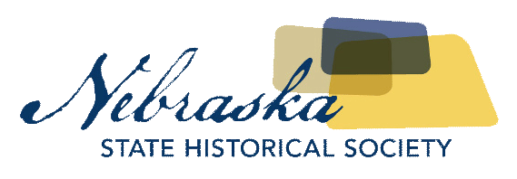
Contact Chris Goforth  Telephone 402-471-3262  Cell 402-219-3597  Email chris.goforth@nebraska.gov  Website http://nebraska.history.gov | MEDIA ADVISORY  FOR IMMEDIATE RELEASE  October 19, 2017

Congressman Fortenberry to donate congressional bill to the Nebraska state historical society

Special Presentation Will Honor Contributions by Yazidi Immigrants
Lincoln, NE, October 19, 2017– Please join the Nebraska State Historical Society on Thursday, October 19 at 10 a.m. at the Nebraska History Museum (P Street and Centennial Mall, North) as Congressman Jeff Fortenberry presents to the Nebraska State Historical Society the congressional bill he sponsored that gives Special Immigrant Visas for those who gave their service to American armed forces between 2001 and 2014. Many of these recipients are Yazidis who have experienced genocide and who reside in Lincoln, the city with the largest Yazidi population in the United States.
For more information on this event and to schedule an interview, please contact Sharon Kennedy at Sharon.kennedy@nebraska.gov.

WHAT: Congressman Fortenberry Presentation to NSHS
WHEN: Thursday, October 19th, 10am
WHERE: Nebraska History Museum, 131 Centennial Mall North (P Street and Centennial Mall North)
WHY: Congressman Jeff Fortenberry will present the Nebraska State Historical Society with the congressional bill he sponsored which gives Special Immigrant Visas to those who gave their service to the United States armed forces between 2001 and 2014.

About The Nebraska State Historical Society
The Nebraska State Historical Society (NSHS) collects, preserves, and opens to all the histories we share. In addition to the Nebraska History Museum in Lincoln and historic sites around the state, NSHS administers the State Archives and Library; the State Historic Preservation Office; the Gerald R. Ford Conservation Center, Omaha; the Office of the State Archeologist; publishes Nebraska History magazine and Nebraska History News; and is responsible for the administration of the Nebraska Hall of Fame Commission. More at History.nebraska.gov or follow us on Facebook.

# # #
If you would like more information about this topic, please contact Chris Goforth at 402-471-3262 or email at chris.goforth@nebraska.gov and Sharon Kennedy at Sharon.kennedy@nebraska.gov.

