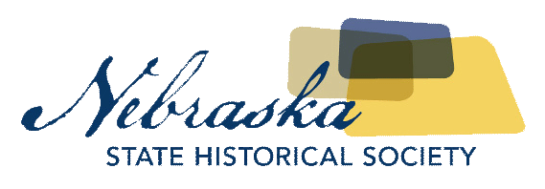
Contact Chris Goforth  Telephone 402-471-3262  Cell 402-219-3597  Email chris.goforth@nebraska.gov  Website http://nebraska.history.gov | FOR IMMEDIATE RELEASE  November 1, 2017

nebraska history museum opens imprinting the west: manifest destiny, real and imagined november 13th

Prints and Engravings Show How Artists Shaped Public Perception of Manifest Destiny
Lincoln, NE, November 1, 2017– Throughout the nineteenth century, as Americans pushed west toward the Pacific, they were fascinated by westward expansion in North America. Printed imagery—lithographs and engravings—played an important role in the dissemination of knowledge and understanding about the West and its inhabitants. Now visitors to the Nebraska History Museum’s new exhibition, Imprinting the West: Manifest Destiny, Real and Imagined, opening November 13th, will see 48 hand-colored engravings and lithographs that explore these depictions and the influence the artists had on the perception of the wild west.
In 1803, President Thomas Jefferson purchased the expansive territory, known as Louisiana from Napoleon, King of France. This transaction extended the young country’s boundaries by 828,000 square miles, including all of present-day Nebraska, Arkansas, Iowa, Kansas, Missouri, Oklahoma, and parts of Colorado, Louisiana, Minnesota, Montana, New Mexico, North Dakota, South Dakota, Texas, and Wyoming. The Louisiana Purchase set the stage for exploration, migration, and settlement, in addition to struggle and conflict. Convinced that God wanted the country to extend to the Pacific Coast—the idea called Manifest Destiny—scores of Americans, including painters and printmakers, moved west.
The westward expansion in the nineteenth century was closely intertwined with the experiences of the native peoples. The exhibition’s artists, including George Catlin and Frederic Remington, sought to document the indigenous people of west along with migration to the west
Artists often accompanied governmental geographical surveys and created images to illustrate official publications. Others sold engravings to popular periodicals, such as Harper’s Weekly, or to the mass market. Whether real or imagined, these lithographs and engravings informed the rest of America and the world about Native Americans and America’s western landscapes and its natural resources.
Join Nancy Gillis for a free public talk about "Manifest Destiny" and its impact on Nebraskans, both native and immigrant. Of Cherokee and Choctaw heritage, Nancy was the executive director at the NSHS's John G. Neihardt State Historic Site and offers talks on Nebraska tribes and settlement through the Humanities Nebraska speakers' bureau.

About The Nebraska State Historical Society
The Nebraska State Historical Society (NSHS) collects, preserves, and opens to all the histories we share. In addition to the Nebraska History Museum in Lincoln and historic sites around the state, NSHS administers the State Archives and Library; the State Historic Preservation Office; the Gerald R. Ford Conservation Center, Omaha; the Office of the State Archeologist; publishes Nebraska History magazine and Nebraska History News; and is responsible for the administration of the Nebraska Hall of Fame Commission. More at History.nebraska.gov or follow us on Facebook.

# # #
If you would like more information about this topic, please contact Chris Goforth at 402-471-3262 or email at chris.goforth@nebraska.gov.

