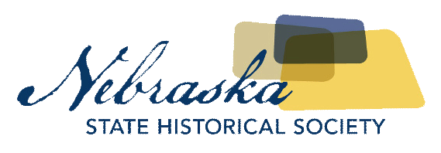
Contact Chris Goforth  Telephone 402-471-3262  Cell 402-219-3597  Email chris.goforth@nebraska.gov  Website http://nebraska.history.gov | FOR IMMEDIATE RELEASE  November 17, 2017

NEBRASKA STATE HISTORICAL SOCIETY TO REPATRIATE REMainS AND OBJECTS TO THE PONCA TRIBE OF NEBRASKA

Transfer to be Completed November 22nd
Lincoln, NE, November 17, 2017– The skeletal remains of 10 individuals along with about 300 funerary objects will be repatriated to the Ponca Tribe of Nebraska on November 22nd. The transfer is being conducted by the Nebraska State Historical Society’s State Archeology Office and the Ponca Tribe of Nebraska under the requirements of the federal Native American Graves Protection and Repatriation Act and the Nebraska Unmarked Human Burial Sites and Skeletal Remains Protection Act.
All remains and objects, many being glass beads, date back to the 1700s and 1800s. They were inadvertently discovered during construction projects in Knox, Platte, and Butler counties. When human skeletal remains and burial goods are discovered and law enforcement determines a crime is not involved, Nebraska State Historical Society Archeology staff will be contacted by the appropriate county attorney's office. Staff members are required to conduct an on-site investigation to determine the origin and identity of the remains and promptly relate the findings in writing to the county attorney and interested parties, who may include: a descendant Indian Tribe, a descendant family, or the Nebraska Indian Commission.
This specific repatriation is a joint project of the Nebraska State Historical Society, The Nebraska Commission on Indian Affairs, and the Ponca Tribe of Nebraska. Tribal members of the Ponca Tribe of Nebraska will reclaim and prepare the remains for transfer and reburial in the Ponca homeland along the lower Niobrara River.
About The Nebraska State Historical Society
The Nebraska State Historical Society (NSHS) collects, preserves, and opens to all the histories we share. In addition to the Nebraska History Museum in Lincoln and historic sites around the state, NSHS administers the State Archives and Library; the State Historic Preservation Office; the Gerald R. Ford Conservation Center, Omaha; the Office of the State Archeologist; publishes Nebraska History magazine and Nebraska History News; and is responsible for the administration of the Nebraska Hall of Fame Commission. More at History.nebraska.gov or follow us on Facebook.

# # #
If you would like more information about this topic, please contact Chris Goforth at 402-471-3262 or email at chris.goforth@nebraska.gov.

