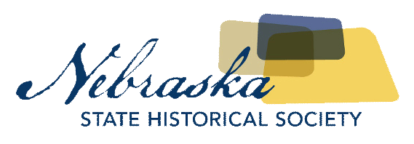
Contact Chris Goforth  Telephone 402-471-3262  Cell 402-219-3597  Email chris.goforth@nebraska.gov  Website http://nebraska.history.gov | FOR IMMEDIATE RELEASE  November 8, 2017

NEBRASKA HISTORY MUSEUM CELEBRATING THE 1970’S WITH AFTER HOURS EVENT

Special Behind the Scenes Tour of Museum Will Be Held
Lincoln, NE, November 8, 2017– The Nebraska History Museum is dusting off the bell bottom pants and feathering their hair for the “70’s Boogie Nights” event Thursday, November 16th. The event is being held in conjunction with the Don’t Touch That Dial exhibit featuring puppets and other artifacts from the Kalamity Kate children’s program.
WHEN: Thursday, November 16th 6:30-9 p.m.
WHERE: Nebraska History Museum, 131 Centennial Mall North
WHAT: Disco dancing with music from the Gittin’ Hipper Fun Bunch, 1970’s inspired food and signature cocktail, VIP Behind-The-Scenes tour of the museum collections, including the recently acquired Miss Nebraska Crown from the 1970s, trivia contest, and special prizes. Take selfies in our 70s style photo booth and tour the Don’t Touch That Dial exhibit.
Advance tickets are available for $20 at history.nebraska.gov or ne.gov/go/70sBoogieNight. Tickets will be available at the door for $25. Each ticket holder will also receive one free drink courtesy of the Nebraska State Historical Society Foundation.

About The Nebraska State Historical Society
The Nebraska State Historical Society (NSHS) collects, preserves, and opens to all the histories we share. In addition to the Nebraska History Museum in Lincoln and historic sites around the state, NSHS administers the State Archives and Library; the State Historic Preservation Office; the Gerald R. Ford Conservation Center, Omaha; the Office of the State Archeologist; publishes Nebraska History magazine and Nebraska History News; and is responsible for the administration of the Nebraska Hall of Fame Commission. More at History.nebraska.gov or follow us on Facebook.

# # #
If you would like more information about this topic, please contact Chris Goforth at 402-471-3262 or email at chris.goforth@nebraska.gov.

