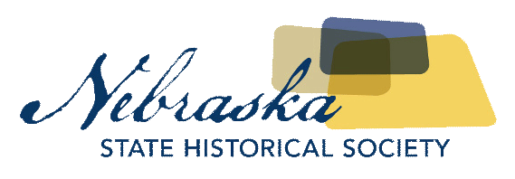
Contact Chris Goforth  Telephone 402-471-3262  Cell 402-219-3597  Email chris.goforth@nebraska.gov  Website http://history.nebraska.gov | FOR IMMEDIATE RELEASE  December 22, 2017

nebraska history museum to open exhibit focusing on immigration to nebraska

“Looking Past Skin” Exhibit Opens January 5th, 2018
Lincoln, NE, December 22, 2017– People have been moving throughout Nebraska for thousands of years. The Nebraska History Museum, the University of Nebraska’s Minority Health Disparities Initiative (MHDI), and Nebraska Extension will present Looking Past Skin: Our Common Threads from January 5th, 2018 through May 15th, 2018. The interactive exhibit explores the movement of people from the earliest Native cultures to the most recent refugee families.
The four-part exhibit will explore sociological, agricultural, and historical perspectives on migration and the most recent demographic shifts in urban and rural parts of the state. A walk through the migration timeline provides a backdrop for additional features on the Karen (kah-REN), Sudanese, and Yazidi (yah-ZEE-dee) communities.
The University’s Wall of Windows combines historical and contemporary photographs accompanied by stories from new Nebraskans including Latino and Somalis living in Dawson County.
The Ask a Doctor exercise reveals the complexities of speaking a non-native language through a simulated visit to the doctor where a language barrier exists.
Food is History explores finding nutritional food and nutrition education in a new country.
Funding for Looking Past Skin: Our Common Threads was generously provided by Rural Families Institute and Humanities Nebraska.

About The Nebraska State Historical Society
The Nebraska State Historical Society (NSHS) collects, preserves, and opens to all the histories we share. In addition to the Nebraska History Museum in Lincoln and historic sites around the state, NSHS administers the State Archives and Library; the State Historic Preservation Office; the Gerald R. Ford Conservation Center, Omaha; the Office of the State Archeologist; publishes Nebraska History magazine and Nebraska History News; and is responsible for the administration of the Nebraska Hall of Fame Commission. More at History.nebraska.gov or follow us on Facebook.

# # #
If you would like more information about this topic, please contact Chris Goforth at 402-471-3262 or email at chris.goforth@nebraska.gov.

