Contact Chris Goforth  Telephone 402-471-3262  Cell 402-219-3597  Email chris.goforth@nebraska.gov  Website http://history.nebraska.gov | FOR IMMEDIATE RELEASE  February 15, 2018

New Study Cites $128.23M Economic Impact and 1,719 Full Time Jobs From Nebraska Historic Tax Credit Program

Lincoln, NE, February 15, 2018–The Nebraska State Historical Society has published a new economic impact study that finds the Nebraska Historic Tax Credit (NHTC) program has generated $128.23M to the Nebraska economy and created 1,719 jobs. A total of $14.99M in tax credits has been claimed since the program began January 1, 2015. Based on the economic impact alone, the State of Nebraska’s return on investment from the NHTC program is approximately 755%.
The study, authored by the Bureau of Business Research at the University of Nebraska-Lincoln, reviewed the cumulative impact of the NHTC program authorized by the Nebraska Job Creation and Mainstreet Revitalization Act of 2014. Commercial and residential rehabilitation projects in Omaha, Norfolk, Fairbury, and Hastings offer compelling evidence investing in preservation pays.
The study suggests that the NHTC program is having the intended effect of contributing to the economic development in areas where the poverty rate is over 40%, with 17 of 23 rehabilitation projects taking place in distressed areas of the state. “Projects supported by the NHTC have created a total of 606 residential units in the state, with 279 of these (including 20 low-income units) being created in distressed areas,” concludes co-authors Dr. Mitchel Herian and Dr. Eric Thompson of the UN-L Bureau of Business Research. “In sum, NHTC rehabilitation projects have resulted in a total of 96,828 square feet of residential and commercial space, with a total of 43,537 square feet being created in distressed areas.”
Other key findings include $57.56M in wages and added $74.48M to the gross state product. Additionally, completed projects contributed $5.37M in state and local taxes.
The impact of the NHTC program is felt across the state. The First Thurston County Courthouse in Pender consists of two buildings, a two story frame structure built in 1889 and the three story brick Palace Hotel. The owner of both buildings utilized the NHTC to offset the total rehabilitation cost of $4.3 million.

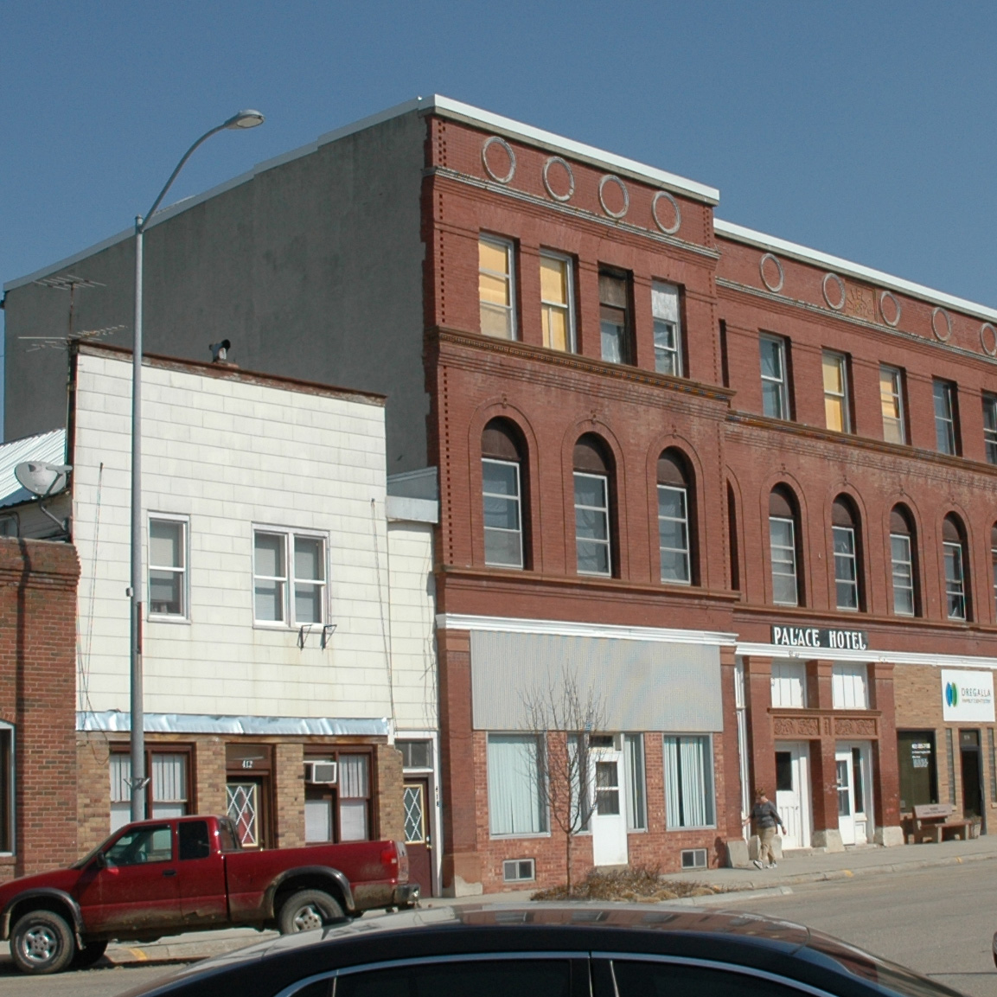
First Thurston County Courthouse Before Rehab/Nebraska State Historical Society
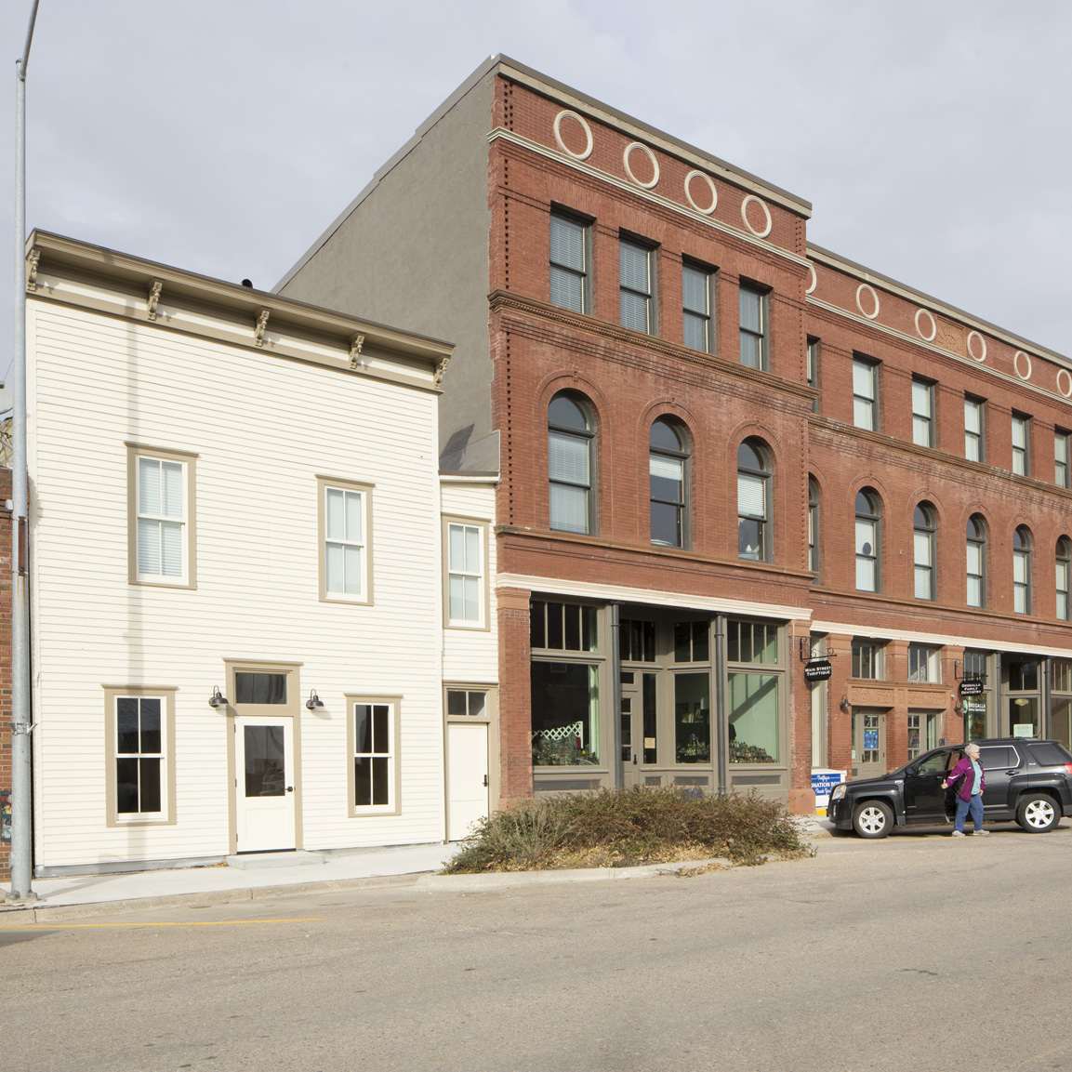
First Thurston County Courthouse After Rehab/Nebraska State Historical Society
In Chadron, the owner of the Weber Brothers building took advantage of the NHTC to rehabilitate the façade of the building.

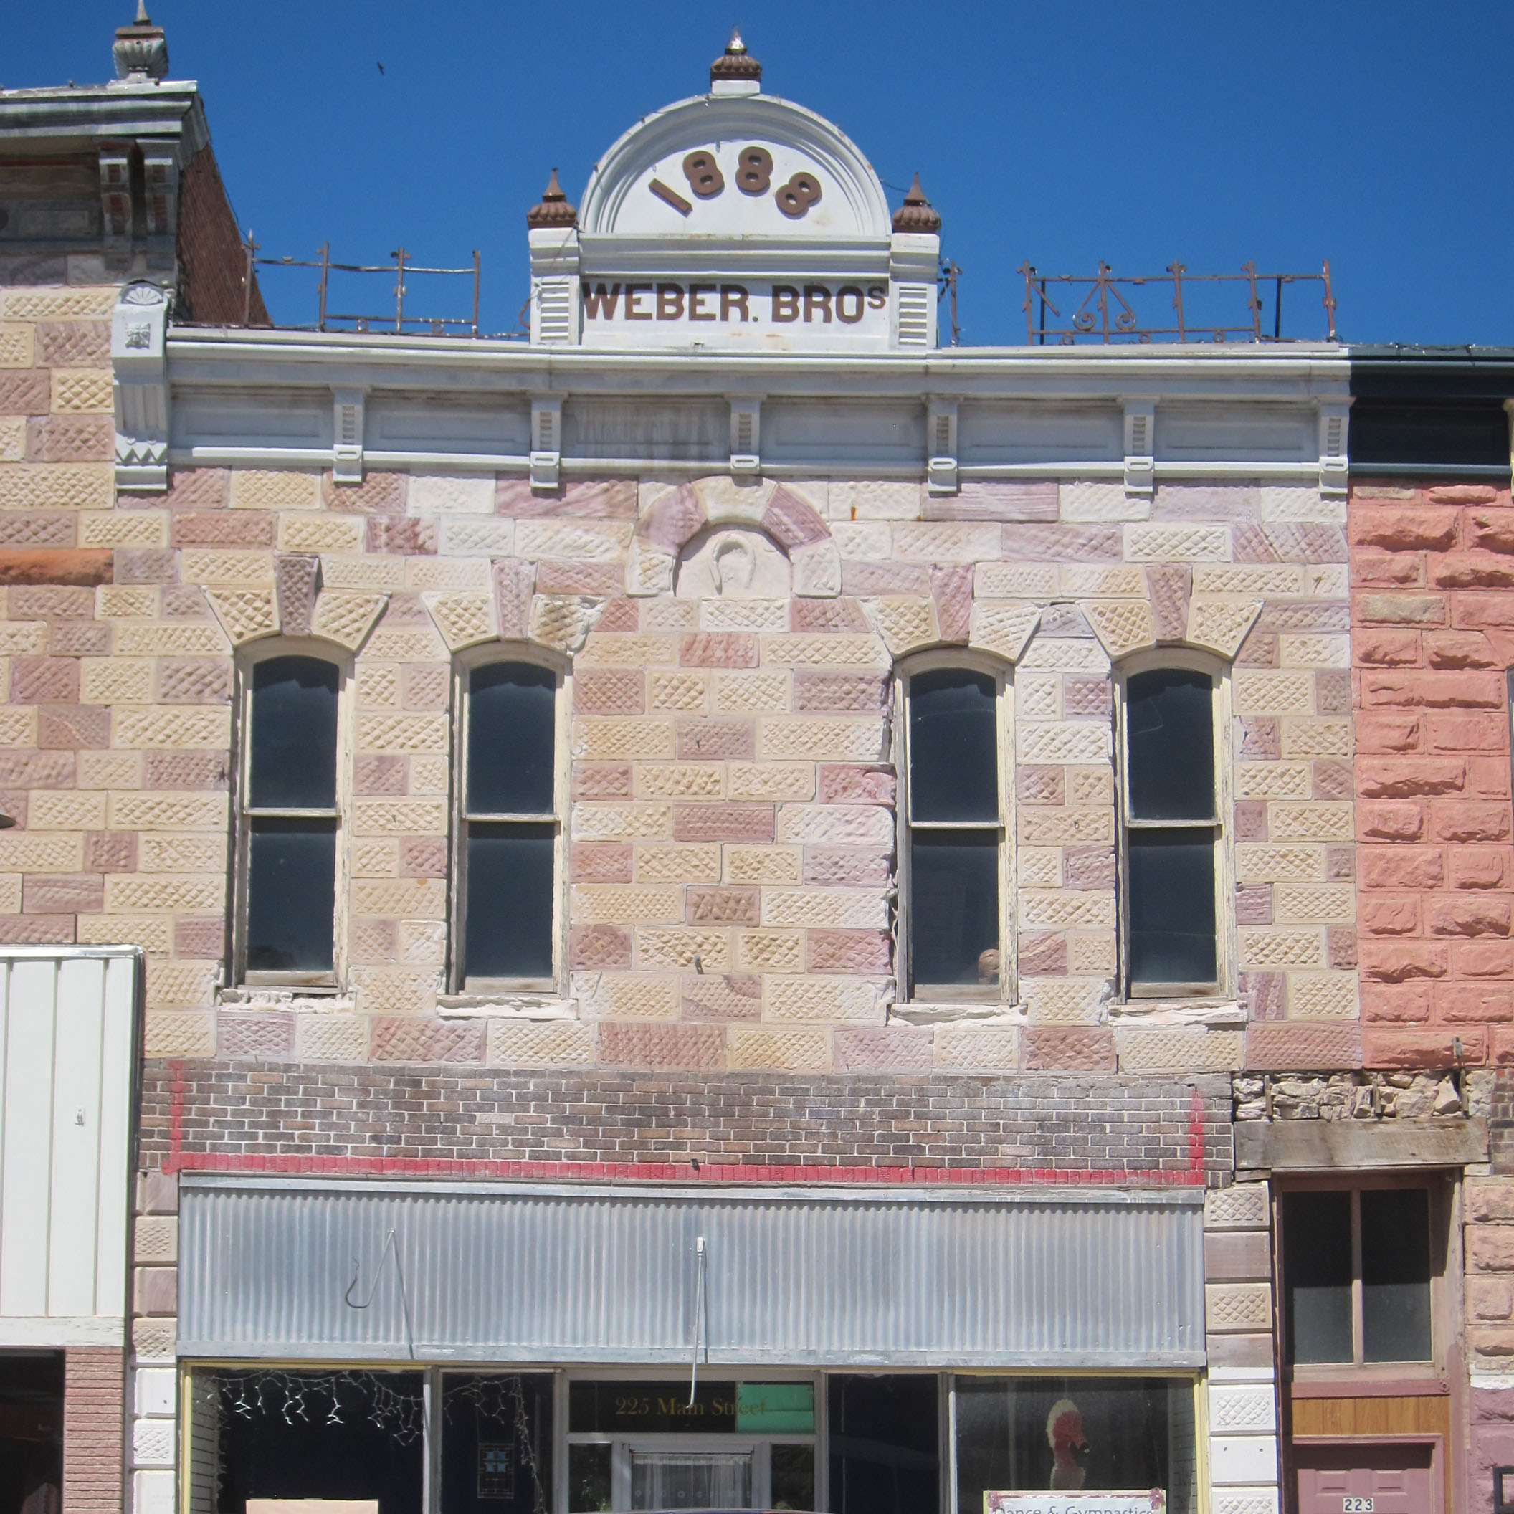
Weber Brothers Building Before Rehab/Nebraska State Historical Society
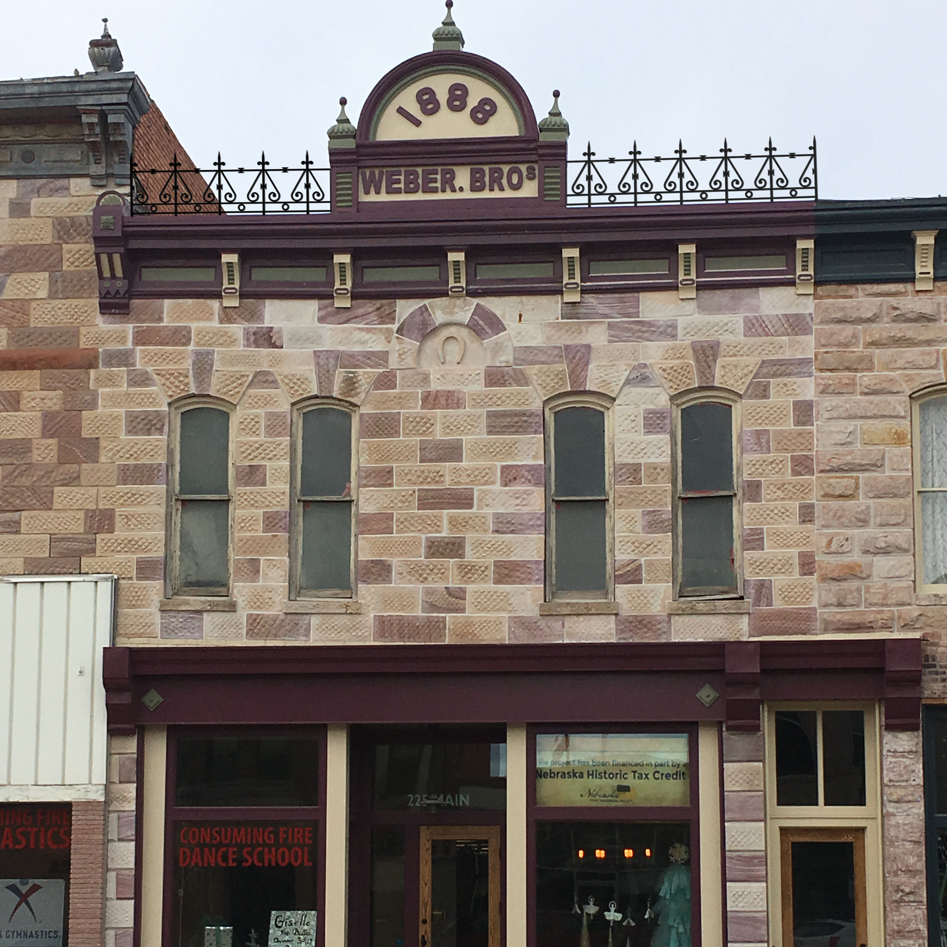
Weber Brothers Building After Rehab/Nebraska State Historical Society

Meanwhile, in Grand Island, the former ornate plaster ceiling in the Hall County Courthouse courtroom was discovered during HVAC work in 2016. The county commissioners removed the drop ceiling and used the NHTC to restore the original plater to preserve the originality of the courthouse.

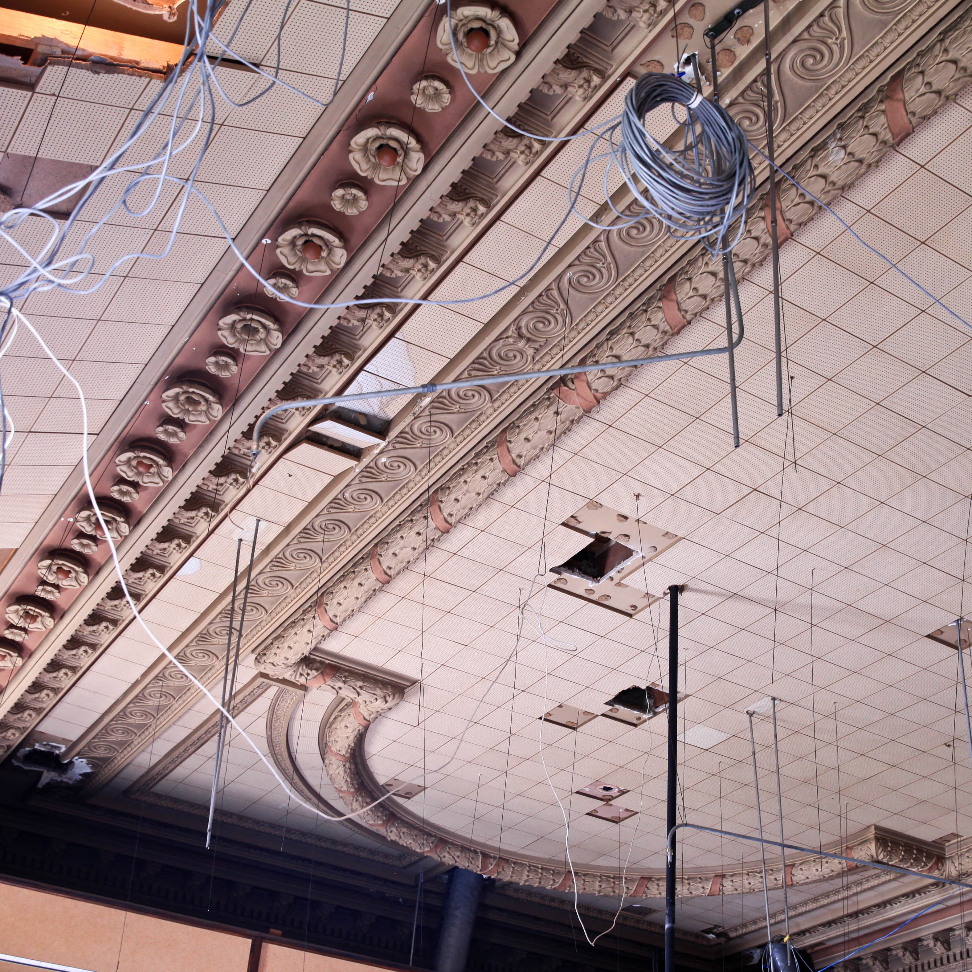
Hall County Courthouse Ceiling Before Rehab/Nebraska State Historical Society

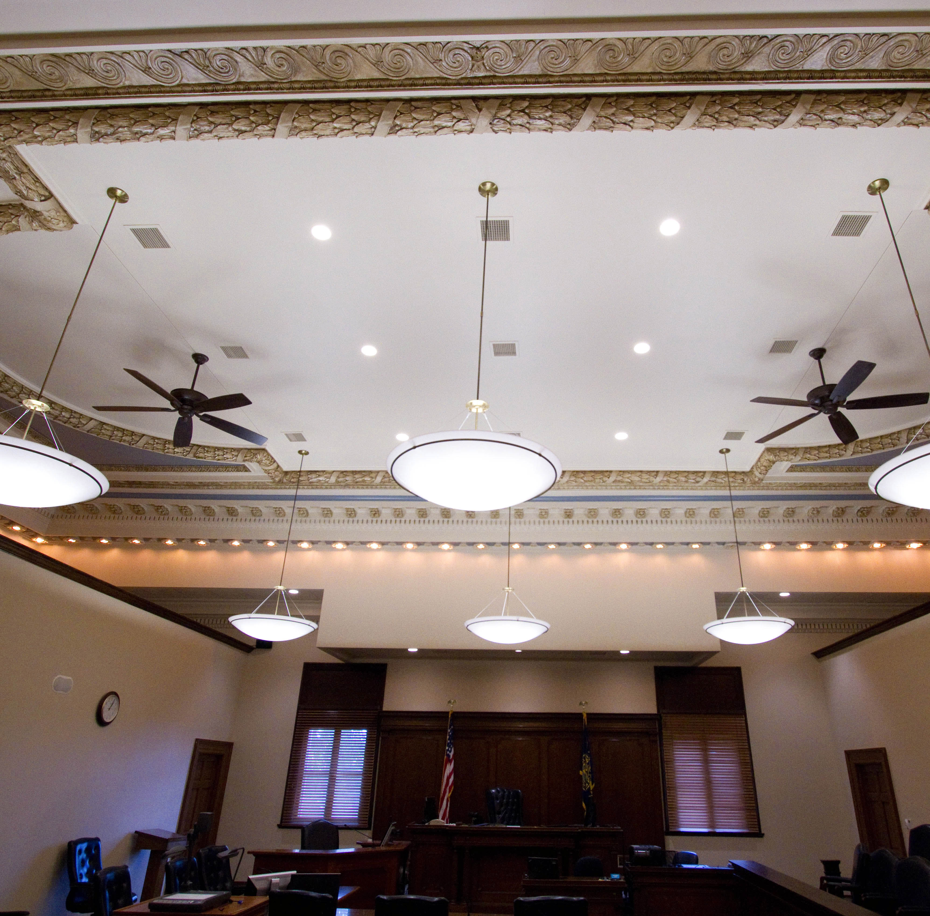
Hall County Courthouse Ceiling After Rehab/Nebraska State Historical Society
Applications for potential tax credit projects are still being accepted by the Nebraska State Historical Society’s State Historic Preservation Office for 2018. The law authorizes a total of $15 million in credits for each calendar year through 2022. The Nebraska State Historical Society’s State Historic Preservation Office administers the program in cooperation with the Nebraska Department of Revenue.
About The Nebraska Historic Tax Credit
The Nebraska Job Creation and Mainstreet Revitalization Act provides a 20 percent state tax credit (up to a limit of $1 million for a single project) for eligible expenditures made for rehabilitating qualified historic buildings and structures. The Nebraska Historic Tax Credits may be used against state income tax, insurance premium taxes and financial institution deposit taxes.
Rehabilitation projects must equal or exceed $25,000 in total cost. For properties in metropolitan or primary class cities, the cost must exceed 25% of the property’s assessed value or $25,000, whichever is greater.
To qualify, a historic property must be listed individually in the National Register of Historic Places, located within a district listed in the National Register of Historic Places, listed individually under a certified local preservation ordinance, or located within a historic district designated under a certified local preservation ordinance. Single-family detached residences do not qualify for the program, but projects can include commercial, multifamily and industrial uses for eligible buildings and structures.
Project work must be executed to standards outlined in the Secretary of the Interior’s “Standards for Rehabilitation.” These standards are designed to preserve the historic building or structure’s fabric and character, while still allowing for rehabilitation and new development. Information about the program can be found at history.nebraska.gov or 402-471-4788.
About The Nebraska State Historical Society
The Nebraska State Historical Society (NSHS) collects, preserves, and opens to all the histories we share. In addition to the Nebraska History Museum in Lincoln and historic sites around the state, NSHS administers the Historical Marker Program; the State Archives and Library; the State Historic Preservation Office; the Gerald R. Ford Conservation Center, Omaha; the Office of the State Archeologist; publishes Nebraska History magazine and Nebraska History e-newsletter; and is responsible for the administration of the Nebraska Hall of Fame Commission. More at History.nebraska.gov or follow us on Facebook.

# # #
If you would like more information about this topic, please contact Chris Goforth at 402-471-3262 or email at chris.goforth@nebraska.gov. For unedited photos, download them at https://www.dropbox.com/sh/bx89pcqlbnf793l/AABHjq5oEGc6TWcgV1ZoziR_a?dl=0.

