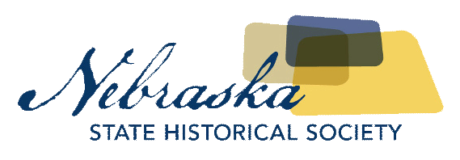
Contact David Calease  Telephone 402-471-4775  Email david.calease@nebraska.gov  Website http://history.nebraska.gov | FOR IMMEDIATE RELEASE  February 7, 2018

Nebraska State Historical Society to Host public Information Meeting for Proposed Cozad National Register of Historic Places Nomination

Lincoln, NE, February 7, 2018– Staff members from the Nebraska State Historical Society’s State Historic Preservation Office will hold a public information meeting to discuss developing a National Register of Historic Places nomination for the Cozad Downtown district. The meeting will be held at 5:30 pm on Thursday, February 15th, 2018, at the Cozad Development Corporation, 121 West 9th Street, Suite E, in Cozad.
David Calease, National Register Program Coordinator for the Nebraska State Historical Society, is inviting the public and business owners within the proposed area to come to the meeting to learn about the National Register of Historic Places program, why the Cozad Downtown district is eligible, and the benefits of designation. The proposed district includes approximately 35-40 properties roughly one block north and one block south of 8th Street, from H Street on the west to F Street on the east.
The National Register of Historic Places is the nation's inventory of properties deemed worthy of preservation. It is part of a national program to coordinate and support local and private efforts to identify, evaluate, and protect the nation's historic and archeological resources. The National Register was developed to recognize historic places and their role in contributing to our country's heritage. Properties listed in the National Register either individually or as contributing to a historic district are eligible for State and Federal tax incentives.
For more information on the National Register program in Nebraska, contact the Nebraska State Historic Preservation Office at the Nebraska State Historical Society at (402) 471-4775 or visit history.nebraska.gov.

About The Nebraska State Historical Society
The Nebraska State Historical Society (NSHS) collects, preserves, and opens to all the histories we share. In addition to the Nebraska History Museum in Lincoln and historic sites around the state, NSHS administers the Historical Marker Program; the State Archives and Library; the State Historic Preservation Office; the Gerald R. Ford Conservation Center, Omaha; the Office of the State Archeologist; publishes Nebraska History magazine and Nebraska History e-newsletter; and is responsible for the administration of the Nebraska Hall of Fame Commission. More at History.nebraska.gov or follow us on Facebook.

# # #
If you would like more information about this topic, please contact David Calease at 402-471-4775 or email at david.calease@nebraska.gov.

