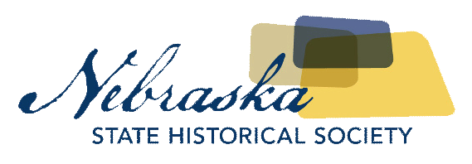
Contact David Calease  Telephone 402-471-4775  Email david.calease@nebraska.gov  Website http://history.nebraska.gov | FOR IMMEDIATE RELEASE  March 20, 2018

Three Nebraska Locations Added to National Register of Historic Places

Emerson, Tekamah, and Venango Added to National Register
Lincoln, NE, March 20, 2018– The Nebraska State Historical Society is pleased to announce that three Nebraska locations have been listed on the National Register of Historic Places. Emerson City Park, Tekamah Auditorium, and Venango Public School were considered and selected by the National Parks Service for listing.
Emerson City Park is a square block between Main and Logan Streets, and 4th and 5th Streets. The Emerson City Park is eligible for listing in the National Register for its association with entertainment and recreation in Emerson. The park includes six contributing resources – four arched entrances, a fountain, and the park site itself – and five resources that do not contribute to the park’s historic character and significance. The park is significant at the local level between the years 1901 to 1968. Today, the park continues to serve as a place of recreation and entertainment for the citizens of Emerson.
The Tekamah Auditorium, located at 1315 K Street in Tekamah, Burt County, is eligible for listing in the National Register for its associated with the New Deal make-work programs, specifically, the Works Progress Administration. The Auditorium is significant at the local level between the years 1938 to 1968. Today, the Auditorium continues to host events as a rented space while the addition built in 1950 houses offices for the City of Tekamah.
Venango Public School is located at 201 East Washington Street in Venango, Perkins County. The Venango Public School is eligible for listing in the National Register for its association with the development of education in Nebraska through expansion and consolidation practice common throughout the state in the 1920s and 1950s. It is also listed due to its significance for embodying distinct architectural characteristics of a type of school building. The school is significant at the local level between the years 1921 to 1965, which includes the original construction of the main building and later additions.
The National Register of Historic Places is the nation's inventory of properties deemed worthy of preservation. It is part of a national program to coordinate and support local and private efforts to identify, evaluate, and protect the nation's historic and archeological resources. The National Register was developed to recognize historic places and their role in contributing to our country's heritage. Properties listed in the National Register either individually or as contributing to a historic district are eligible for State and Federal tax incentives.
For more information on the National Register program in Nebraska, contact the Nebraska State Historic Preservation Office at the Nebraska State Historical Society at (402) 471-4775 or visit history.nebraska.gov. For full versions of the photos, please click here.
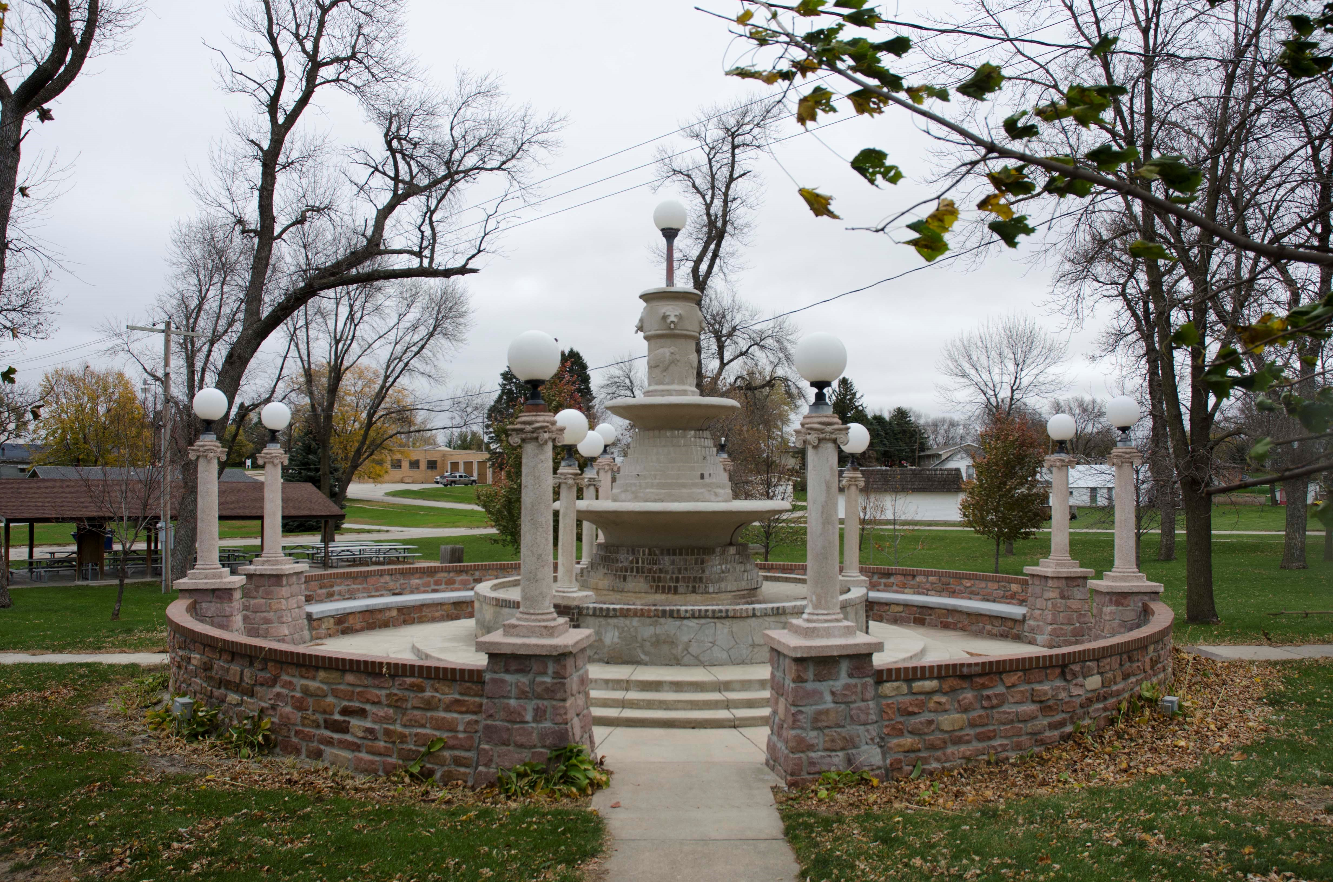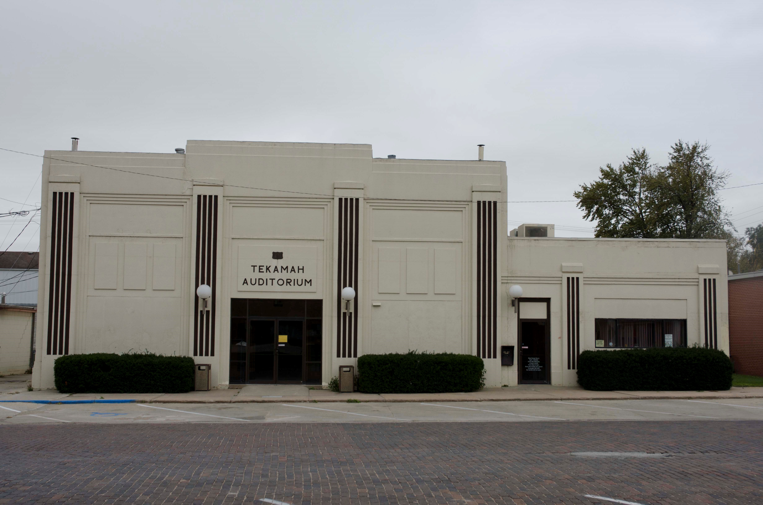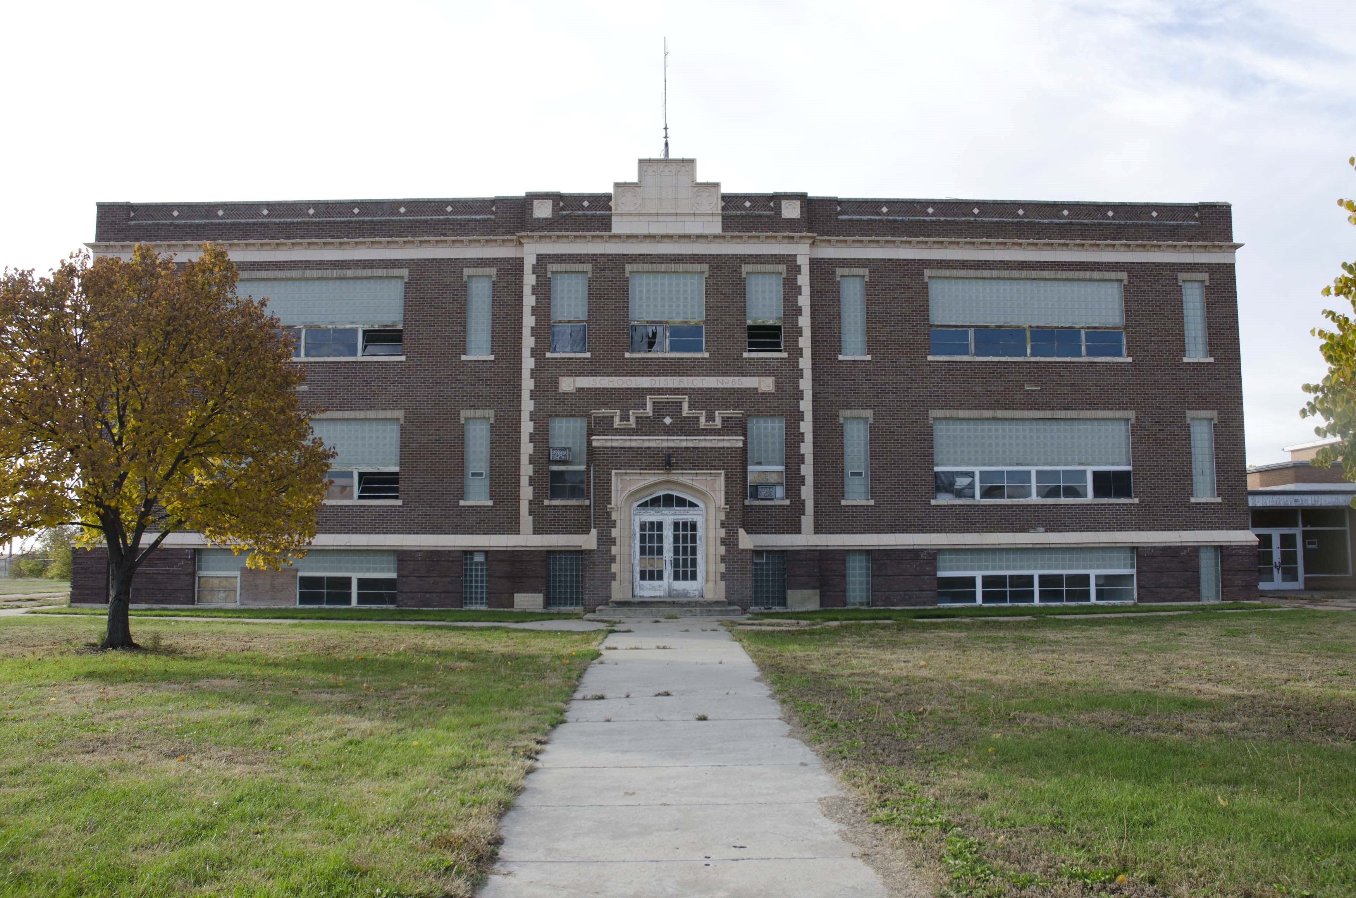

About The Nebraska State Historical Society
The Nebraska State Historical Society (NSHS) collects, preserves, and opens to all the histories we share. In addition to the Nebraska History Museum in Lincoln and historic sites around the state, NSHS administers the State Archives and Library; the State Historic Preservation Office; the Gerald R. Ford Conservation Center, Omaha; the Office of the State Archeologist; publishes Nebraska History magazine and Nebraska History News; and is responsible for the administration of the Nebraska Hall of Fame Commission. More at History.nebraska.gov or follow us on Facebook.

# # #
If you would like more information about this topic, please contact David Calease at 402-471-4775 or email at david.calease@nebraska.gov.

