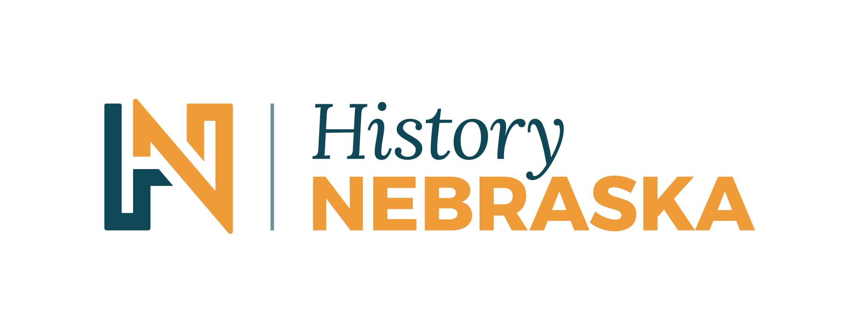
Contact Chris Goforth  Telephone 402-471-3262  Cell 402-219-3597  Email chris.goforth@nebraska.gov  Website http://history.nebraska.gov | FOR IMMEDIATE RELEASE  April 30, 2018

Nebraska State Historical Society Announces New Name and Brand

History Nebraska Officially Launches April 30, 2018
Lincoln, NE, April 30, 2018– It’s a historic day for Nebraska as the Nebraska State Historical Society, the only statewide organization dedicated to preserving and sharing the state’s rich history, announced a rebrand and name change to History Nebraska. The new name will provide History Nebraska opportunities to reach new audiences and connect all Nebraskans to their shared past.
“Last year, we conducted statewide research to see how Nebraskans relate to us,” said Trevor Jones, Director & CEO of History Nebraska. “We found that Nebraskans love their history and the services we provide, but they rarely knew the full scope of what we do. With a new brand and name, we have the opportunity to reach new audiences and connect them to amazing historical resources.”
With the largest collection of Nebraska history materials in the world, History Nebraska’s new brand further enables the organization to showcase its role as the central place to learn about the state’s past and apply those lessons to our lives today.
Featuring a new name and logo, a new website, mobile app, and an engaging approach to history on social media, History Nebraska will provide new ways to access the state’s history. Visitors to the website will find engaging events, access to History Nebraska’s collections, and daily blog posts geared toward sharing unique Nebraska stories with visitors. The new brand also allows History Nebraska to place their services under one easily remembered name.
The organization will continue to provide access to its materials in a number of ways, but Jones states there will also be a new emphasis on reaching people where they are: “We will focus on the public’s needs and the way that people learn today. By directing resources towards our website, social media, and our Explore Nebraska History app, Nebraskans will have access to our resources at their fingertips.”
Additionally, History Nebraska has adopted a new tagline: “Preserving the Past, Building the Future.” The new logo visually represents history pushing Nebraska into the future. These combined elements speak to the core of History Nebraska’s mission to connect all Nebraskans and “open to all the stories we share.” Learn more at history.nebraska.gov
About History Nebraska
History Nebraska collects, preserves, and shares Nebraska’s history for all people. History Nebraska operates the Nebraska History Museum in Lincoln and historic sites around the state including Chimney Rock National Historic Site, Fort Robinson History Center, Neligh Mill State Historic Site, Thomas Kennard State Historic Site, Senator George Norris State Historic Site, John Neihardt State Historic Site, Willa Cather State Historic Site, and over 500 historical markers placed across Nebraska. History Nebraska administers the State Archives and Library; the State Historic Preservation Office; the Gerald R. Ford Conservation Center; the Office of the State Archeologist; publishes Nebraska History magazine and books; and is responsible for the administration of the Nebraska Hall of Fame Commission. More at history.nebraska.gov and follow us on Facebook, Instagram, and Twitter.
For high resolution copies of our new logo, please click here.
# # #
If you would like more information about this topic, please contact Chris Goforth at 402-471-3262 or email at chris.goforth@nebraska.gov.

