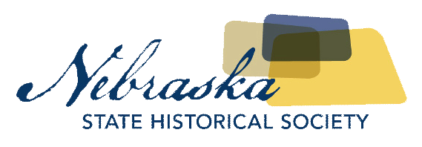
Contact Laura Mooney  Telephone 402-471-4780  Email Laura.mooney@nebraska.gov  Website http://history.nebraska.gov | FOR IMMEDIATE RELEASE  August 10, 2017

don’t touch that dial exhibit to open august 18th at the nebraska history museum

Exhibit Features Lincoln’s Own Kalamity Kate
Lincoln, NE, August 10, 2017– The Nebraska History Museum’s newest exhibit “Don’t Touch That Dial: Kalamity Kate and the George Churley Puppets” will open August 18th and run until June 17th, 2018. The exhibit will feature puppets created by George Churley that were prominently featured on the KOLN/KGIN program Kalamity Kate’s Cartoon Corral and hundreds of live programs during the 1970’s. Visitors will also be able to see the original Kalamity Kate costume worn by Leta Powell Drake, as well as film footage, including a brief interview with Drake about the history of the program, clips of the opening and closing theme songs, kids competing in Little Reggie’s Quiz Kids, and more.
Kalamity Kate’s Cartoon Corral and the George Churley Puppet Company touched the lives of many Nebraska children during the 1970s. They regularly tuned in to the locally-produced children’s program hosted by Leta Powell Drake on KOLN/KGIN television from 1967 to 1980. Puppets designed and brought to life by the George Churley Puppet Company joined the show in 1975.
Thousands of children in seventy-two Nebraska counties and parts of Northern Kansas watched on weekdays. The George Churley Puppet Company also gave educational workshops, demonstrations, and live performances that brought puppetry to audiences throughout Nebraska and beyond.
Cartoon Corral, like many other children’s television shows across the nation, first featured a local host who showed cartoons and interacted with a live studio audience. Later scripted puppet segments and a game-show style quiz segment earned it national recognition. Cartoon Corral was cited as one of five nationwide examples of “excellence in local children’s programming” by the National Television Information Office.
Kalamity Kate’s Cartoon Corral and the George Churley puppets are still fondly remembered by the many Nebraskans who watched the show from home, interacted with a puppeteer in their classroom, or were part of the studio audience and got to tell Kalamity Kate what they wanted to be when they grew up.
About The Nebraska State Historical Society
The Nebraska State Historical Society (NSHS) collects, preserves, and opens to all the histories we share. In addition to the Nebraska History Museum in Lincoln and historic sites around the state, NSHS administers the State Archives and Library; the State Historic Preservation Office; the Gerald R. Ford Conservation Center, Omaha; the Office of the State Archeologist; publishes Nebraska History magazine and Nebraska History News; and is responsible for the administration of the Nebraska Hall of Fame Commission. More at History.nebraska.gov or follow us on Facebook.
# # #
If you would like more information about this topic, please contact Laura Mooney at 402-471-4780 or email at Laura.mooney@nebraska.gov.

