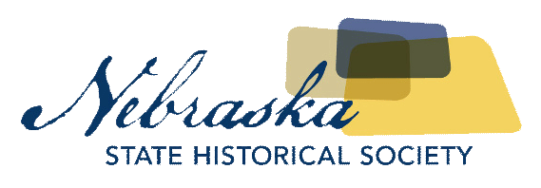
Contact Chris Goforth  Telephone 402-471-3262  Cell 402-219-3597  Email chris.goforth@nebraska.gov  Website http://nebraska.history.gov | FOR IMMEDIATE RELEASE  August 17, 2017

Nebraska state historical society awards five historic preservation grants to communities

Lincoln, North Platte, Omaha, Plattsmouth, and Red Cloud Receive Grants
Lincoln, NE, August 17, 2017– The Nebraska State Historical Society and the Nebraska State Historic Preservation Office awarded Certified Local Government grants to five communities to assist in their respective preservation efforts.
Lincoln was awarded a $24,000 grant to further historic preservation training, development of an online story map, and city staff expenses.
North Platte was awarded a $14,145 grant to assist in the creation of a Historic Preservation Handbook. The handbook will help guide the city in future historic preservation priorities and projects, and include general design guidelines.
Omaha was awarded a $44,200 grant to assist in survey, training, and research of the historic Omaha streetcar lines. The grant will be applied to Phase II of an intensive level survey of the historic Omaha streetcar commercial nodes and historic preservation training. The survey researches and documents the commercial buildings associated with Omaha’s streetcar lines.
Plattsmouth was awarded a $13,200 grant to assist in the research and writing of two National Register of Historic Places nominations, the development of a website and app for historic walking tours, and historic preservation training.
Red Cloud was awarded a $3,990 Certified Local Government grant to assist in the development of signage for the community’s historic street car route.
Jill Dolberg, Deputy State Historic Preservation Officer with the Nebraska State Historical Society, says the diversity of the grants make them useful for any community. “Certified Local Government grants are designed to assist communities is so many ways. These grants are a great example of the diversity of historic preservation efforts in Nebraska. We encourage every town and city to learn more about how these grants could benefit their preservation work.”

About The Nebraska State Historical Society
The Nebraska State Historical Society (NSHS) collects, preserves, and opens to all the histories we share. In addition to the Nebraska History Museum in Lincoln and historic sites around the state, NSHS administers the State Archives and Library; the State Historic Preservation Office; the Gerald R. Ford Conservation Center, Omaha; the Office of the State Archeologist; publishes Nebraska History magazine and Nebraska History News; and is responsible for the administration of the Nebraska Hall of Fame Commission. More at http://history.nebraska.gov or follow us on Facebook.
About The Certified Local Government Program
The Certified Local Government program is a community-wide preservation assistance program. It is a network of communities working on similar historic preservation goals. Certified Local Governments have the authority to locally landmark properties and write National Register of Historic Places nomination forms making the properties potentially eligible for historic tax incentives when undergoing substantial rehabilitation. They can write design guidelines for historic properties and require the city to review proposed changes to historic properties. For more information on the CLG Program, contact Kelli Bacon at the Nebraska State Historical Society at kelli.bacon@nebraska.gov or 402-471-4766.
# # #
If you would like more information about this topic, please contact Chris Goforth at 402-471-3262 or email at chris.goforth@nebraska.gov.

