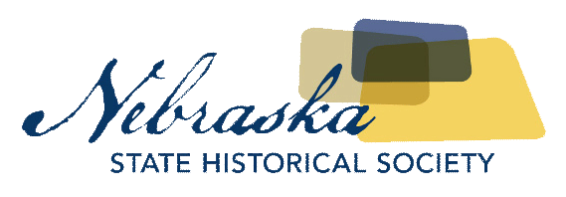

|  |  |  |  |  |  |  |  |  |  |  |  |
| --- | --- | --- | --- | --- | --- | --- | --- | --- | --- | --- | --- |
| |  |  | | --- | --- | | Contact | Chris Goforth | | Telephone | 402-471-3262 | | Cell | 402-219-3597 | | Email | chris.goforth@nebraska.gov | | Website | http://nebraska.history.gov | | MEDIA ADVISORYFOR IMMEDIATE RELEASEAugust 28, 2017 |

Free family fun day – archeology at the kennard house

Discover The History of One of Lincoln’s Oldest Homes

Lincoln, NE, August 28, 2017– The Nebraska State Historical Society is hosting the September Free Family Fun Day at the Historic Thomas P. Kennard House on Saturday, September 9th. We would appreciate the opportunity to promote this event on any of your programs and on your websites.

For more information on this event and to schedule an interview, please contact Sharon Kennedy at [Sharon.kennedy@nebraska.gov](mailto:Sharon.kennedy@nebraska.gov).

**WHAT:** Free Family Fun Day – Archeology at the Kennard House

**WHEN:** Saturday, September 9th, 1p-4p

**WHERE:** Thomas P. Kennard House, 1627 H Street

**WHY:** Built by the first Secretary of State in 1869, the Kennard House was one of the first significant structures built in the new capital of Nebraska. Now you have the chance to participate in a live archeological dig at the Kennard House, meet with an archeologist from the Nebraska State Historical Society, see artifacts excavated from the house, tour the Nebraska Statehood Memorial, learn more about our first Secretary of State, and participate in unique and fun Victorian games!

About The Nebraska State Historical Society  
The Nebraska State Historical Society (NSHS) collects, preserves, and opens to all the histories we share.  In addition to the Nebraska History Museum in Lincoln and historic sites around the state, NSHS administers the State Archives and Library; the State Historic Preservation Office; the Gerald R. Ford Conservation Center, Omaha; the Office of the State Archeologist; publishes *Nebraska History* magazine and *Nebraska History News*; and is responsible for the administration of the Nebraska Hall of Fame Commission. More at History.nebraska.gov or follow us on Facebook.

# # #

If you would like more information about this topic, please contact Chris Goforth at 402-471-3262 or email at chris.goforth@nebraska.gov and Sharon Kennedy at Sharon.kennedy@nebraska.gov.