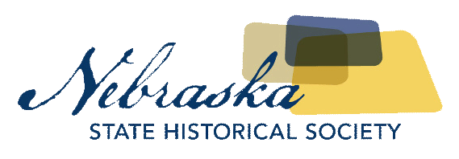
Contact Chris Goforth  Telephone 402-471-3262  Cell 402-219-3597  Email chris.goforth@nebraska.gov  Website http://nebraska.history.gov | MEDIA ADVISORY  FOR IMMEDIATE RELEASE  September 12, 2017

Nebraska State Historical SOciety Hosting ‘Nebraska Archeology Month’ Event

Public is Encouraged to Bring Arrowheads and Other Archeological Artifacts for Identification
Lincoln, NE, September 12, 2017– The Nebraska State Historical Society will celebrate Nebraska Archeology Month with a special presentation at Custer County Museum in Broken Bow, Saturday, September 23rd at 1pm.
WHAT: Archeology of the Sandhills and High Plains
WHEN: Saturday, September 23rd 1pm
WHERE: Custer County Museum, 445 S 9th Ave, Broken Bow, NE, 68822
WHO: Free event, open to the public
WHY: State Archeologist Rob Bozell to discuss archeological research being conducted in the Sandhills and High Plains of Nebraska. The public is encouraged to bring arrowheads and other archeological artifacts to be identified by State Archeologist team. The event is sponsored by the Nebraska State Historical Society Archeology and Historic Preservation offices. Nebraska Archeology Month is organized by the Nebraska Association of Professional Archeologists.
For more information, please contact Rob Bozell at rob.bozell@nebraska.gov.

About The Nebraska State Historical Society
The Nebraska State Historical Society (NSHS) collects, preserves, and opens to all the histories we share. In addition to the Nebraska History Museum in Lincoln and historic sites around the state, NSHS administers the State Archives and Library; the State Historic Preservation Office; the Gerald R. Ford Conservation Center, Omaha; the Office of the State Archeologist; publishes Nebraska History magazine and Nebraska History News; and is responsible for the administration of the Nebraska Hall of Fame Commission. More at History.nebraska.gov or follow us on Facebook.

# # #
If you would like more information about this topic, please contact Chris Goforth at 402-471-3262 or email at chris.goforth@nebraska.gov.

